**USER MANUAL**

**A Guide to Use Homework To-Do**

*Created by Mimi*

1. **Landing Page (For Student)**
   1. You’ll be greeted by the landing page.

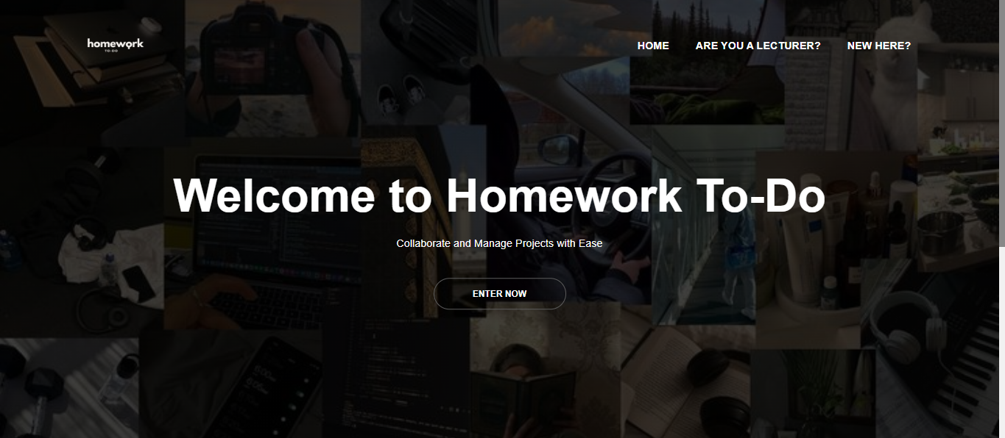

1. **Sign Up and Sign In.**
   1. Visit the sign up, login page to enter your informations (name, email, password and semester).

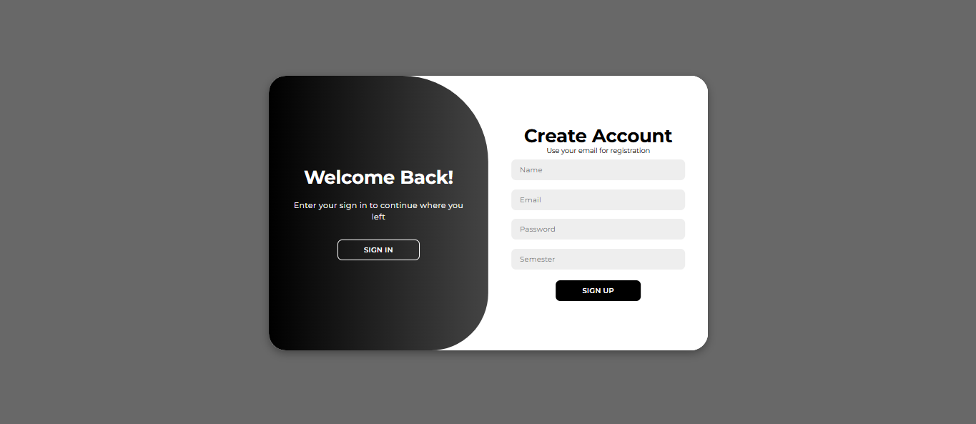

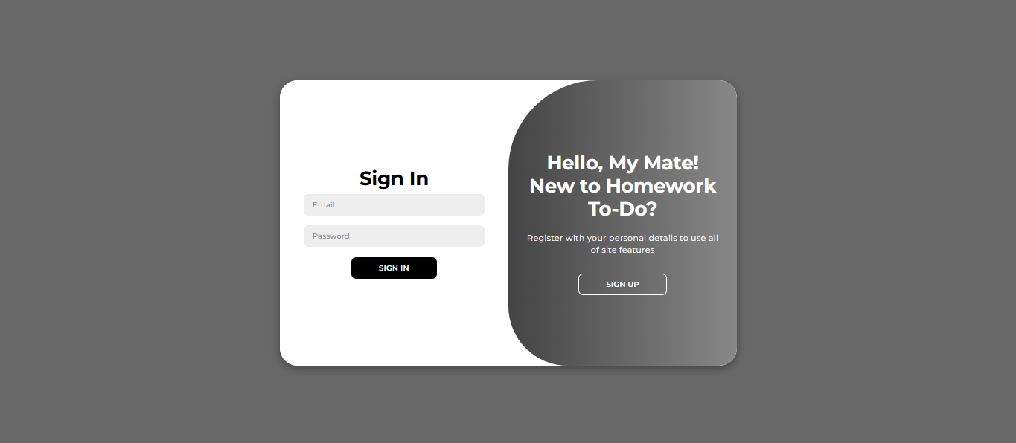

* 1. Once logged in, you’ll be directed to the **Dashboard**.

1. **Dashboard**
   1. Click the **Dashboard** icon on the sidebar.

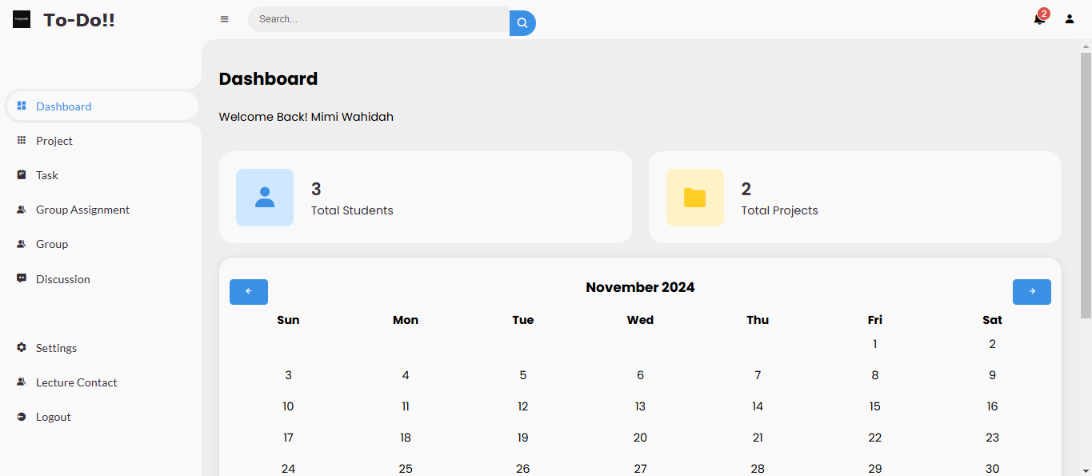

* 1. **Features:**
     1. View a summary of:
        1. Total number of students and projects registered.
     2. Check the **Calendar** for upcoming events.
        1. Navigate between months using the arrow buttons.
     3. See a list of:
        1. Projects and tasks are both to check the progress.

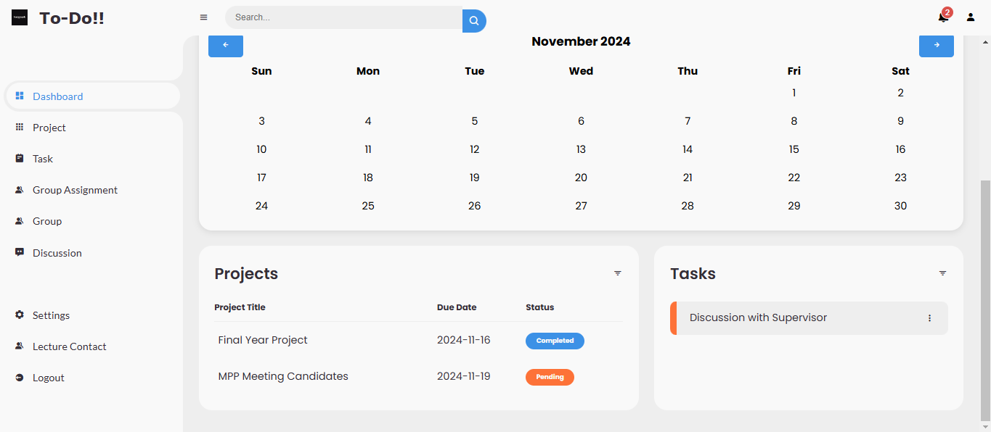

1. **Notifications**
   1. Notifications are to show project’s due date. Every time you login to your account.

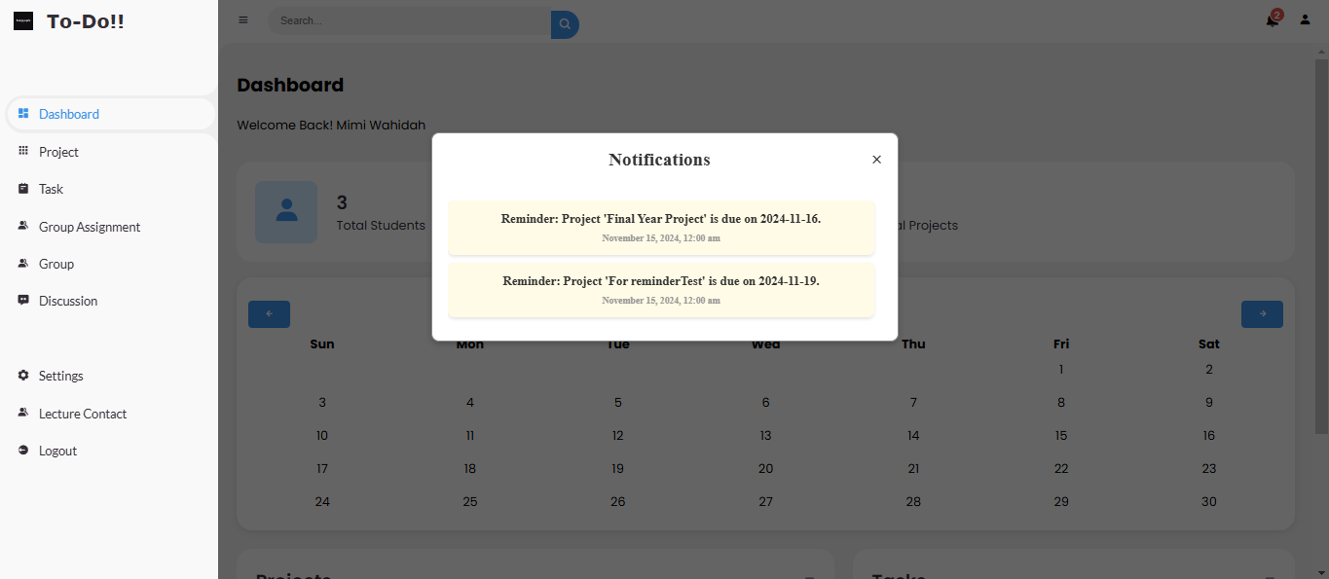

* 1. **Features**:
     1. View reminders for upcoming project deadlines.
     2. Notifications marked as unread are highlighted.

1. **Profile**
   1. Profile to show your detail. Click on the Profile icon to view your details.

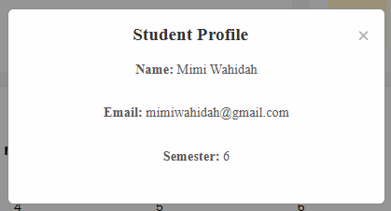

1. **Projects**
   1. Click the **Project** icon on the sidebar.

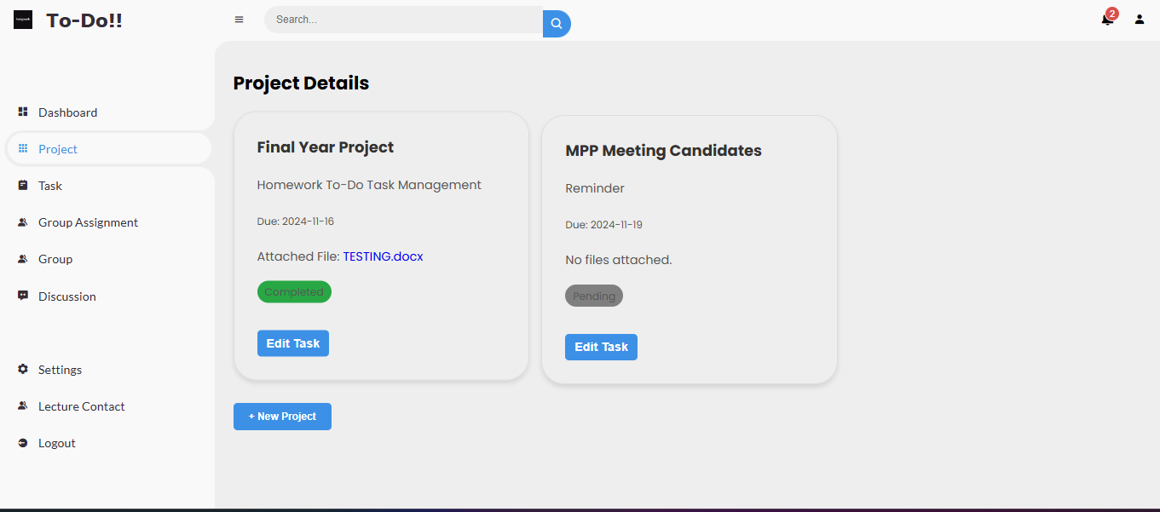

* 1. **Features:**
     1. **View Projects:**
        1. Check project details, such as description, due date, status, and attached files.
     2. **Add New Project:**
        1. Click the + New Project button.
        2. Fill in the project details (name, description, due date, status, and file upload).
        3. Submit the form to save the project.

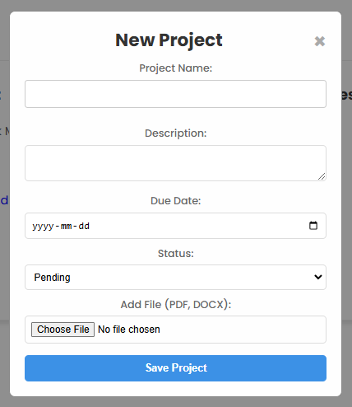

* + 1. **Edit Project:**
       1. Click the **Edit Task** button on any project.
       2. Modify the details and save changes.

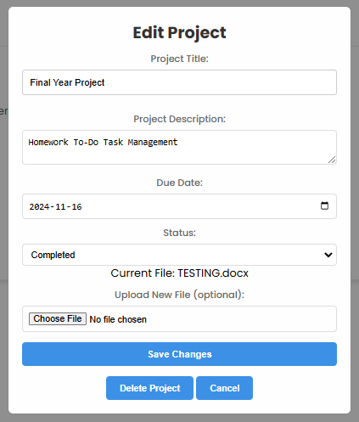

* + 1. **Delete Project:**
       1. Use the delete option inside the project edit form.

1. **Tasks**
   1. Click the **Task** icon on the sidebar.

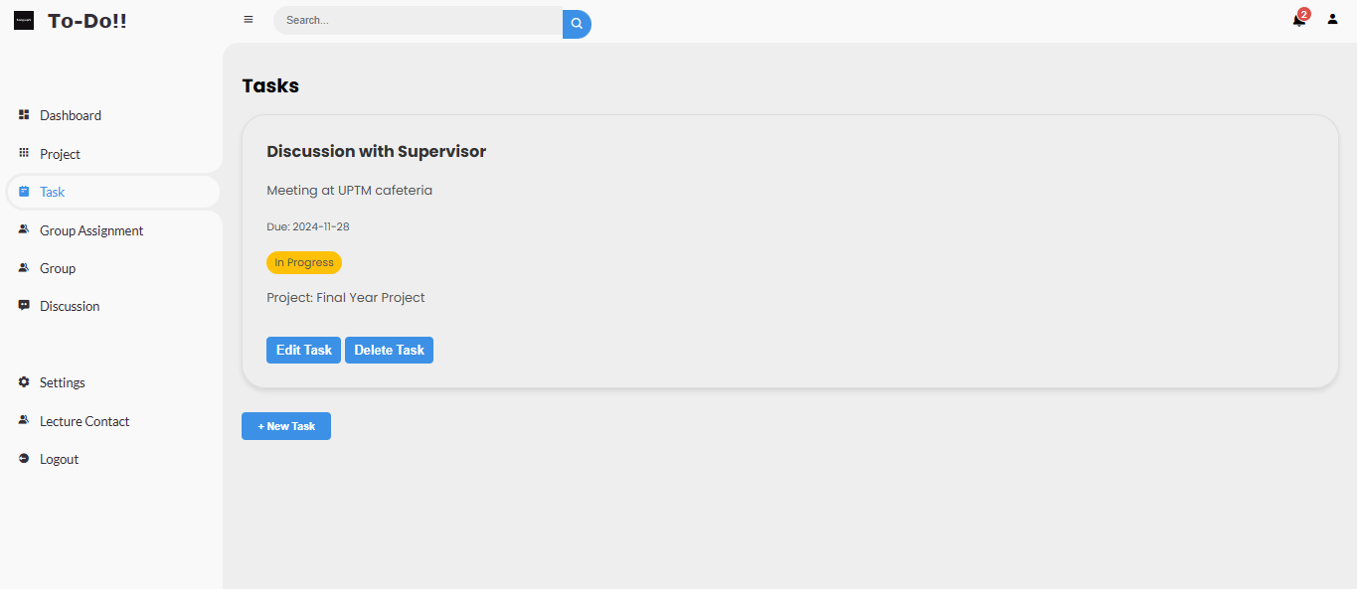

* 1. **Features:**
     1. **View Tasks:**
        1. Check task details, including description, due date, status, and associated project.
     2. **Add New Task:**
        1. Click the + New Task button.
        2. Fill in task details (name, description, due date, status, and associated project).
        3. Submit the form to save the task.

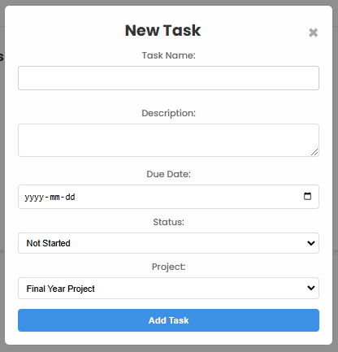

* + 1. **Edit Task:**
       1. Click the **Edit Task** button on any task.
       2. Modify the details and save changes.

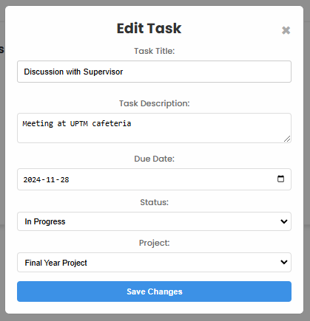

* + 1. **Delete Task:**
       1. Use the delete option inside the task view.

1. **Group Assignment**
   1. Click the **Group Assignment** icon on the sidebar.

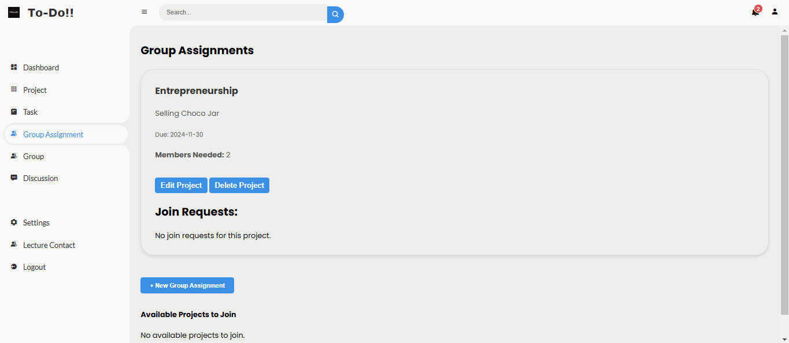

* 1. **Features:**
     1. View all group assignments.
     2. Check your role (member or leader) and project progress, edit and add new group project.

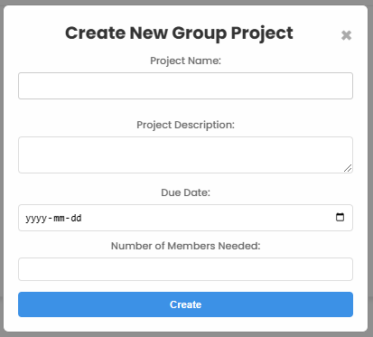

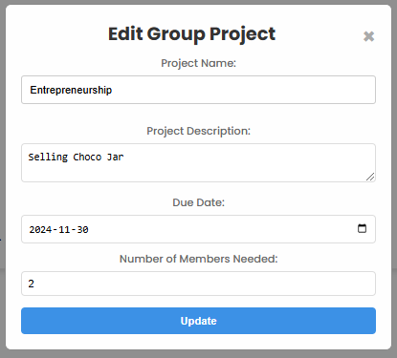

* + 1. Approve or reject group members if you’re the group leader.

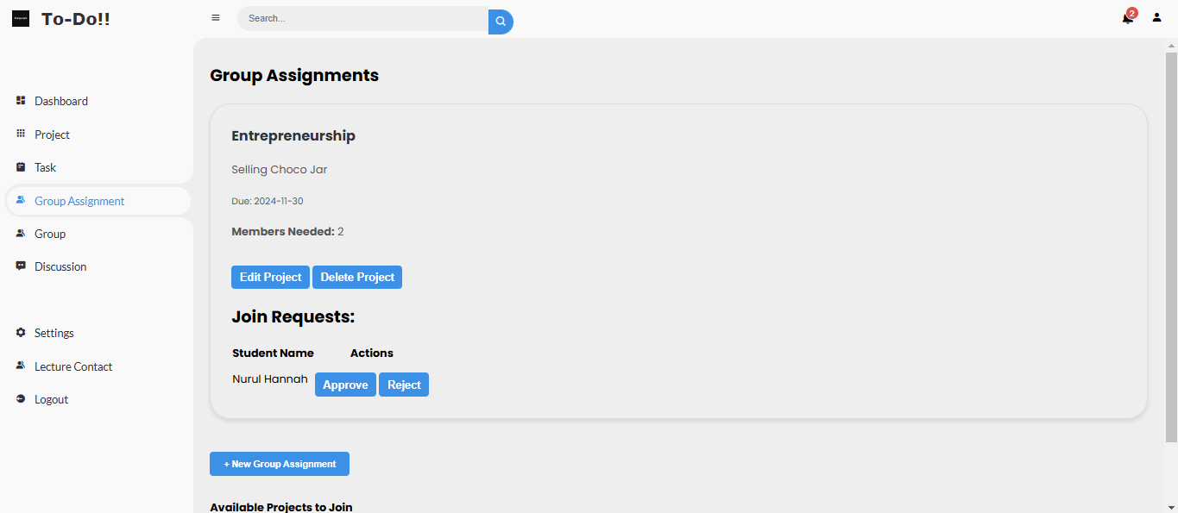

* + 1. Request to join the available group. (Non-Leader)

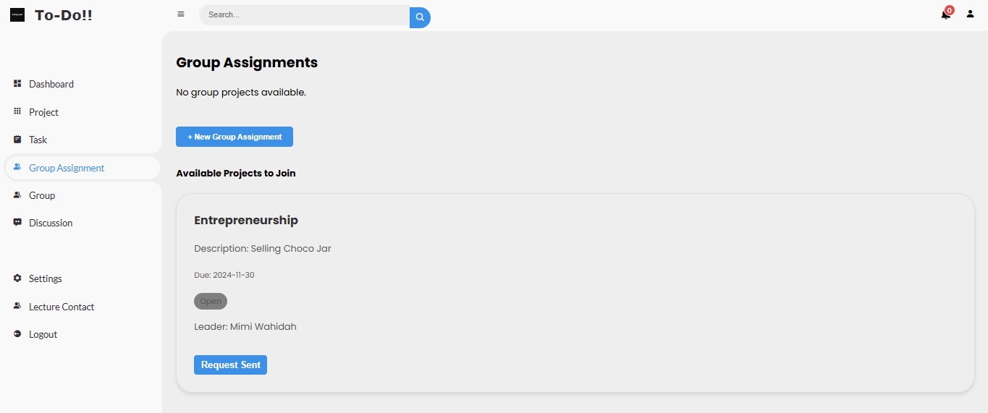

1. **Groups**
   1. **Access:** Click the **Group** icon on the sidebar.

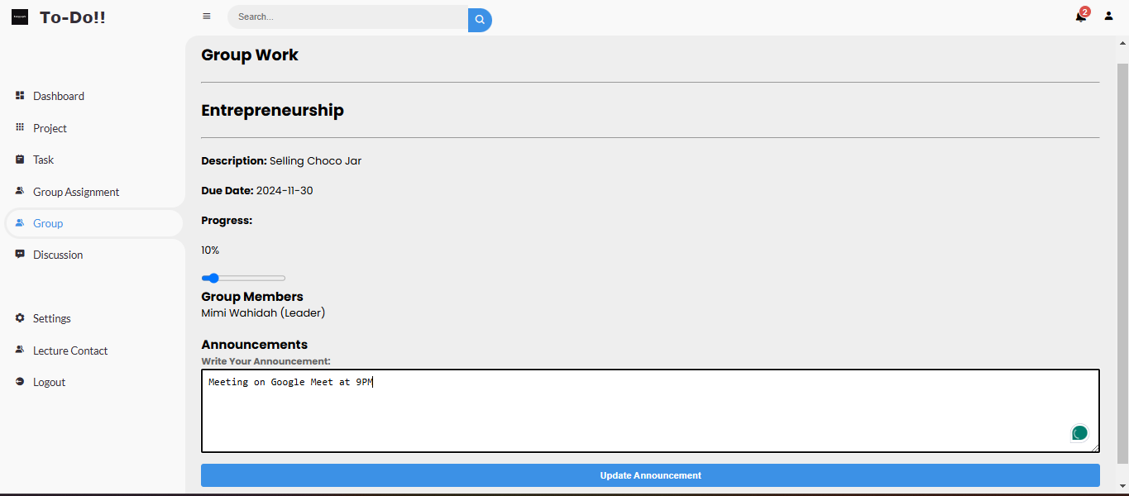

* 1. **Features:**
     1. **Manage Groups:**
        1. View group details, including members, leader, and status.
     2. **Features:**
        1. Announcement can be made by anyone in the group.

1. **Discussion**
   1. Click the **Discussion** icon on the sidebar then click on the “Go to Discussion”.

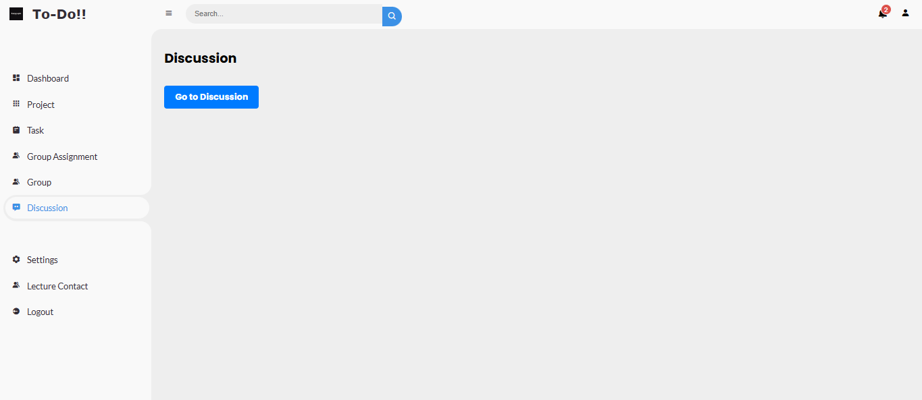

* 1. **Features:**
     1. Participate in topic threads.
     2. Post new questions or comments related to assignments or group projects.

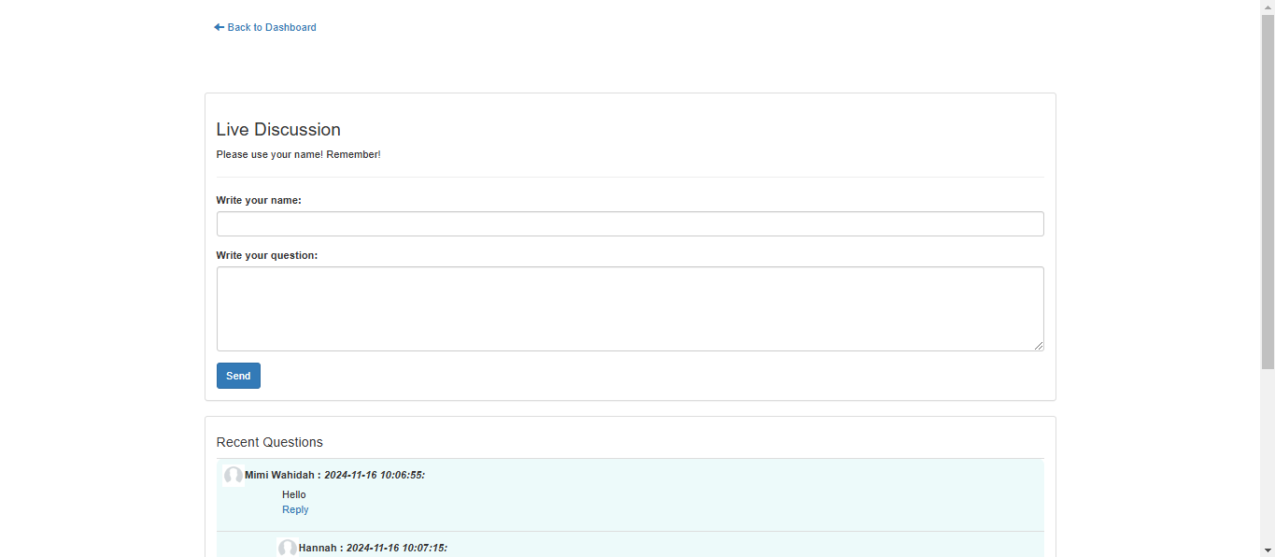

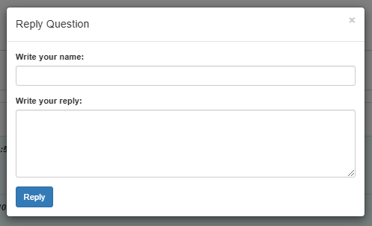

1. **Settings**
   1. Click the **Settings** icon on the sidebar.

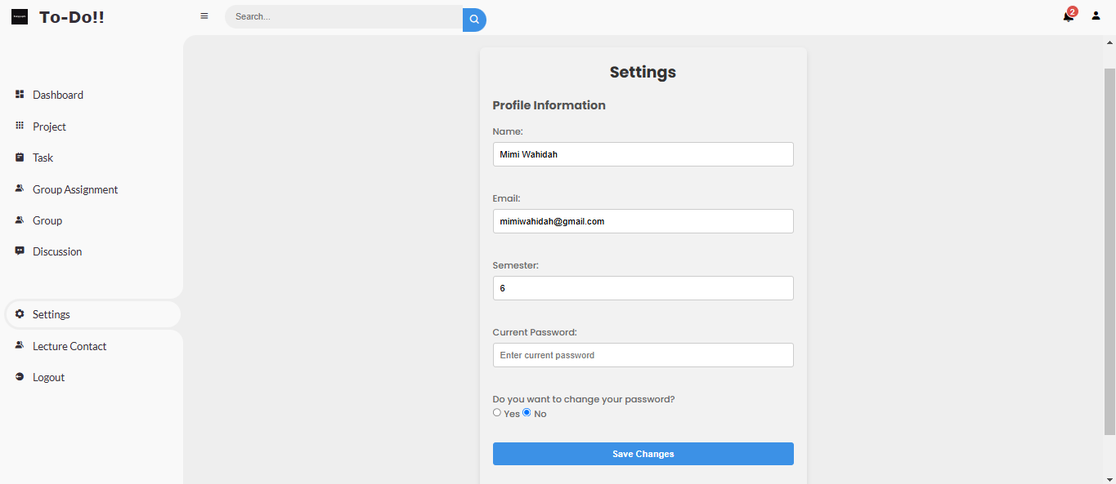

* 1. **Features:**
     1. Update your profile details (name, email).
     2. Change your password.

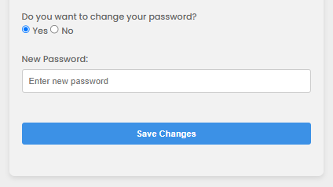

1. **Lecture Contact**
   1. Click the **Lecture Contact** on the sidebar.

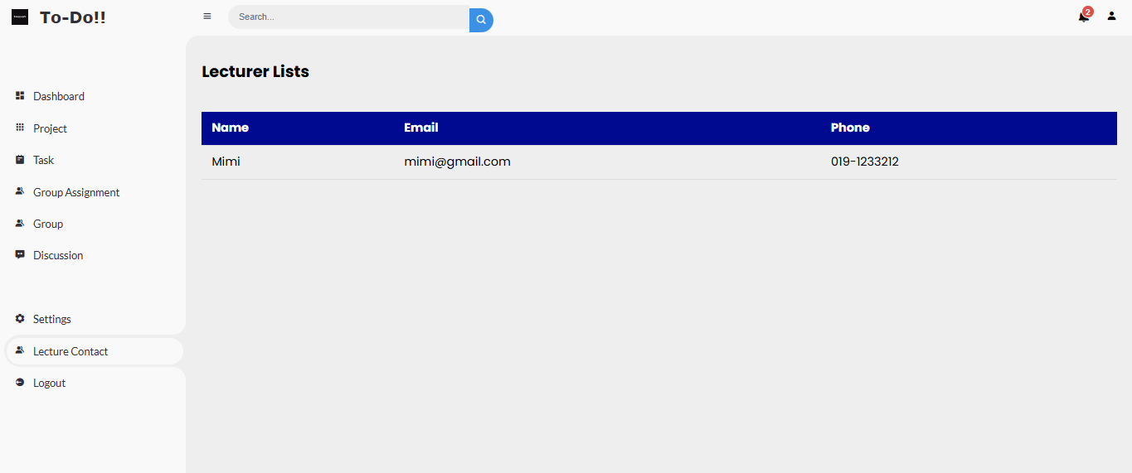

* 1. **Purpose:** To show lists lecture’s contact information for student’s reference.

1. **Logout**
   1. Click the **Logout** icon on the sidebar.

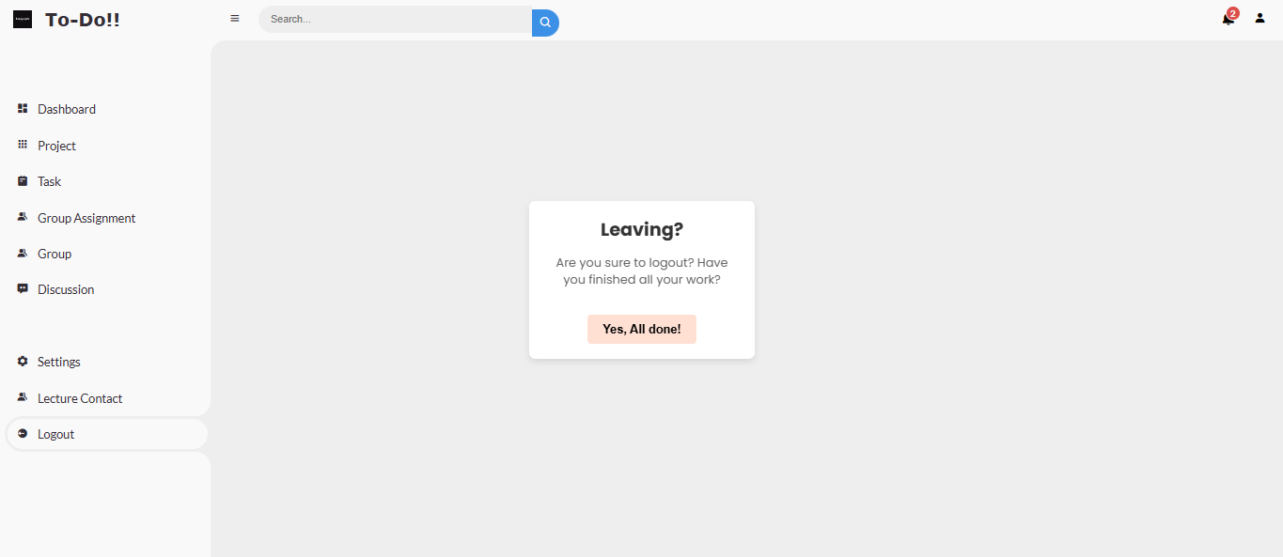

* 1. **Purpose:** Safely exit the Homework To-Do website.

1. **Landing Page (For Lecture and monitoring student’s interaction)**
   1. Click on “ARE YOU A LECTURER?”

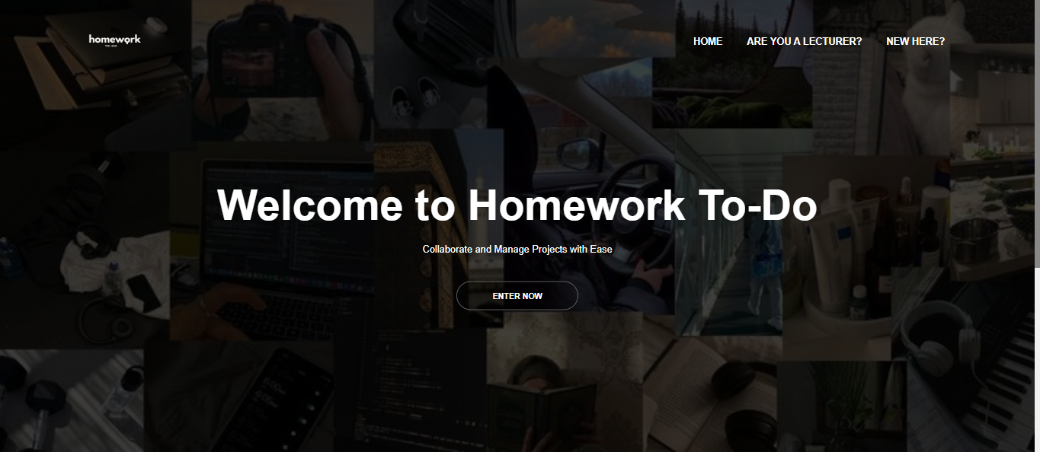

1. **Sign Up and Sign In.**
   1. Visit the sign up, login page to enter your informations (name, email, password and phone number).

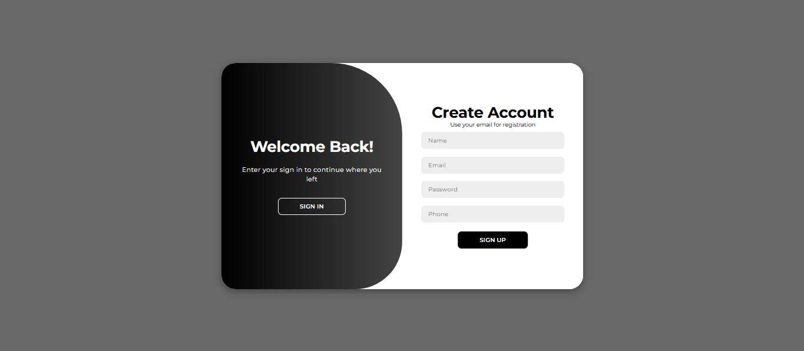

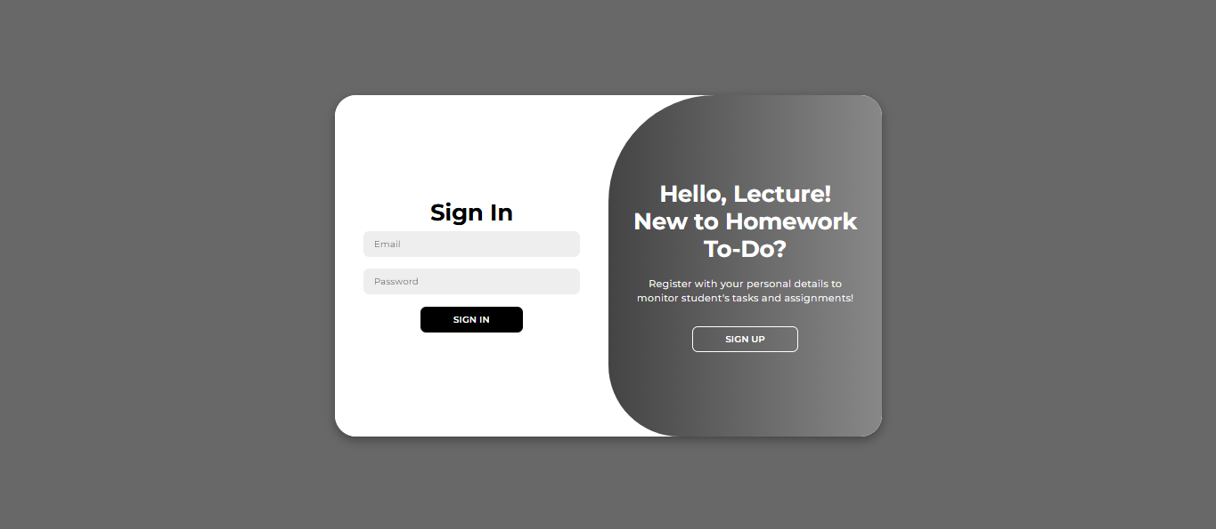

1. **Dashboard**
   1. Click the **Dashboard** icon on the sidebar.

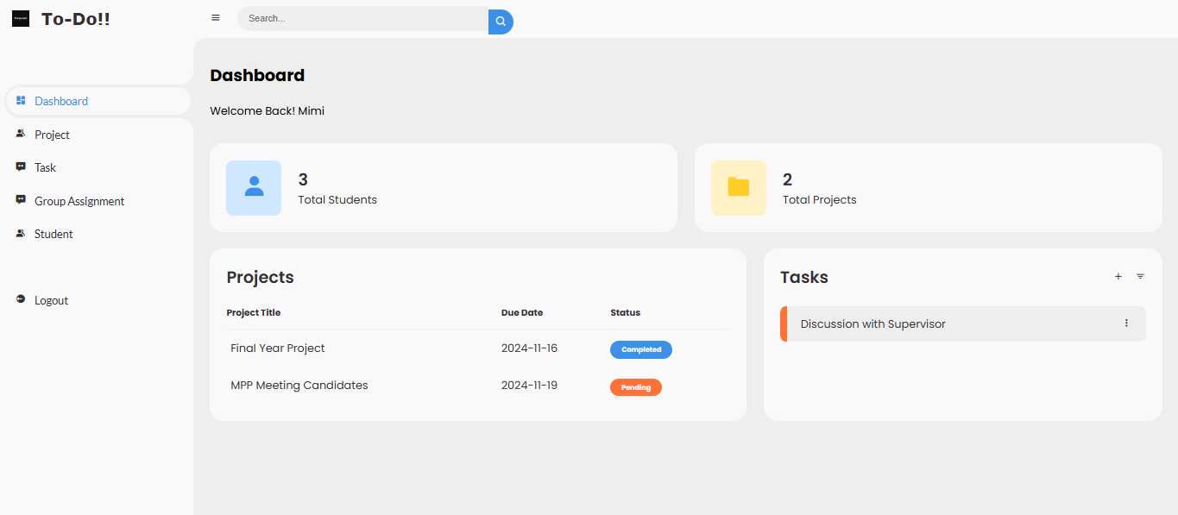

1. **Sidebar**
   1. Project, Task, Group assignment, Student, and Discussion are view-only.

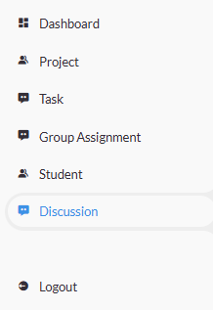

1. **Logout**
   1. Click the **Logout** icon on the sidebar.

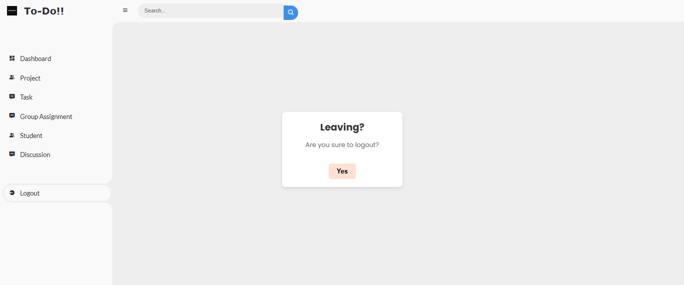

* 1. **Purpose**: Safely exit the Homework To-Do website.

**Thank You! Please Enjoy the Homework To-Do!!**

*Created by Mimi*